Лабораторна робота №6

з дисципліни „Об’єктно-орієнтоване програмування”
Делегати
Мета: Одержати практичні навички створення та роботи з делегатами.
Задача 1 В проєкті до Задачі з ЛР5 (с#) програмно реалізувати декілька делегатів(2-4), застосовуючи різні способи їх використання. Прокоментувати алгоритм роботи з делегатами в проєкті.
Лістинг програми

DELEGATES.CS
using System;
using System.Collections.Generic;
using System.Linq;
using System.Text;
using System.Threading.Tasks;

namespace lr1_3
{
public delegate void TheaterAddedHandler(Theater t);

public delegate bool TheaterValidator(Theater t);
}

THEATEREVENTARGS.CS
using System;
using System.Collections.Generic;
using System.Linq;
using System.Text;
using System.Threading.Tasks;

namespace lr1_3
{
public class TheaterEventArgs : EventArgs
{
public Theater Theater { get; set; }
public string Message { get; set; }

public TheaterEventArgs(Theater t, string msg)
{
Theater = t;
Message = msg;
}
}
}

SCHEDULE.CS
namespace lr1_3
{
public class Schedule
{
public TimeSpan StartTime { get; set; }
public int DurationMinutes { get; set; }

public Schedule(TimeSpan start, int duration)
{
StartTime = start;
DurationMinutes = duration;
}

public override string ToString()
{
return $"{StartTime:hh\\:mm} ({DurationMinutes} хв)";
}
}
}

GROUP.CS
using System;
using System.Collections;
using System.Collections.Generic;

namespace lr1_3
{
public class Group : IEnumerable<Theater>
{
private readonly List<Theater> items = new();

public event TheaterAddedHandler? TheaterAdded;
public event EventHandler<TheaterEventArgs>? GroupCleared;
public event Func<Theater, bool>? FilterUsed;

public void Add(Theater item)
{
if (item != null)
{
items.Add(item);
TheaterAdded?.Invoke(item);
}
}

public void Clear()
{
items.Clear();
GroupCleared?.Invoke(this, new TheaterEventArgs(null, "Групу очищено"));
}

public IEnumerable<Theater> Filter(Func<Theater, bool> predicate)
{
FilterUsed?.Invoke(null);
foreach (var t in items)
{
if (predicate(t))
yield return t;
}
}

public IEnumerator<Theater> GetEnumerator() => items.GetEnumerator();
IEnumerator IEnumerable.GetEnumerator() => items.GetEnumerator();
}
}

THEATERFACTORY.CS
namespace lr1_3
{
public class TheaterFactory
{
public OperaTheater CreateOperaTheater(
string name,
string genre,
string description,
DateTime date,
string composer,
string language,
bool subtitles)
{
return new OperaTheater
{
Name = name,
Genre = genre,
Description = description,
Date = date,
Composer = composer,
Language = language,
Subtitles = subtitles
};
}

public PuppetTheater CreatePuppetTheater(
string name,
string genre,
string description,
DateTime date,
string puppetType,
string ageCategory)
{
return new PuppetTheater
{
Name = name,
Genre = genre,
Description = description,
Date = date,
PuppetType = puppetType,
AgeCategory = ageCategory
};
}
}
}

REPORTER.CS
namespace lr1_3
{
public class TheaterReporter
{
public string ShortInfo(Theater t)
{
return $"[{t.Category}] {t.Name} — {t.Date:dd.MM.yyyy}";
}
}
}

CLASS1.CS
using System;
using System.Collections.Generic;
using System.Linq;
using System.Text;
using System.Threading.Tasks;

namespace lr1_3
{
public class Theater
{
public string Name { get; set; }
public string Genre { get; set; }
public string Description { get; set; }
public DateTime Date { get; set; }
public string Category { get; set; }
public Schedule Schedule { get; private set; }

public void SetSchedule(TimeSpan start, int duration)
{
Schedule = new Schedule(start, duration);
}

public static bool operator ==(Theater t1, Theater t2)
{
if (t1 is null && t2 is null) return true;

if (t1 is null || t2 is null) return false;

return t1.Name == t2.Name &&
t1.Genre == t2.Genre &&
t1.Description == t2.Description &&
t1.Date.Date == t2.Date.Date;
}

public static bool operator !=(Theater t1, Theater t2)
{
return !(t1 == t2);
}

public override bool Equals(object? obj)
{
if (obj is Theater other)
return this == other;
return false;
}

public override int GetHashCode()
{
return HashCode.Combine(Name, Genre, Description, Date.Date);
}

public override string ToString()
{
return $"{Name} ({Genre}) — {Date:dd.MM.yyyy}, Розклад: {Schedule}";

}
}

public class OperaTheater : Theater
{
public string Composer { get; set; }
public string Language { get; set; }
public bool Subtitles { get; set; }
public string PuppetType { get; set; }
public string AgeCategory { get; set; }

public OperaTheater()
{
Category = "Оперний";
PuppetType = null;
AgeCategory = null;
}
public override string ToString()
{
string subs = Subtitles ? "з субтитрами" : "без субтитрів";
return $"{Name} (Опера) — Композитор: {Composer}, Мова: {Language}, {subs}, {Date:dd.MM.yyyy}";
}

public static bool operator ==(OperaTheater t1, OperaTheater t2)
{
if (t1 is null && t2 is null) return true;

if (t1 is null || t2 is null) return false;

return t1.Name == t2.Name &&
t1.Genre == t2.Genre &&
t1.Description == t2.Description &&
t1.Date.Date == t2.Date.Date &&
t1.Composer == t2.Composer &&
t1.Language == t2.Language &&
t1.Subtitles == t2.Subtitles;
}

public static bool operator !=(OperaTheater t1, OperaTheater t2)
{
return !(t1 == t2);
}

public override bool Equals(object? obj)
{
if (obj is OperaTheater other)
return this == other;
return false;
}

public override int GetHashCode()
{
return HashCode.Combine(Name, Genre, Description, Date.Date, Composer, Language, Subtitles);
}

}

public class PuppetTheater : Theater
{
public string PuppetType { get; set; }
public string AgeCategory { get; set; }

public string Composer { get; set; }
public string Language { get; set; }
public bool Subtitles { get; set; }

public PuppetTheater()
{
Category = "Ляльковий";
Composer = null;
Language = null;
Subtitles = false;
}
public override string ToString()
{
return $"{Name} (Ляльковий театр) — Тип: {PuppetType}, Вікове обмеження: {AgeCategory}, {Date:dd.MM.yyyy}";
}

public static bool operator ==(PuppetTheater t1, PuppetTheater t2)
{
if (t1 is null && t2 is null) return true;

if (t1 is null || t2 is null) return false;

return t1.Name == t2.Name &&
t1.Genre == t2.Genre &&
t1.Description == t2.Description &&
t1.Date.Date == t2.Date.Date &&
t1.PuppetType == t2.PuppetType &&
t1.AgeCategory == t2.AgeCategory;
}

public static bool operator !=(PuppetTheater t1, PuppetTheater t2)
{
return !(t1 == t2);
}

public override bool Equals(object? obj)
{
if (obj is PuppetTheater other)
return this == other;
return false;
}

public override int GetHashCode()
{
return HashCode.Combine(Name, Genre, Description, Date.Date, PuppetType, AgeCategory);
}
}
}
FORM1.CS
using System.ComponentModel;
using System.Data;
using System.Text.Json;
using System.Windows.Forms;
using static System.Runtime.InteropServices.JavaScript.JSType;

namespace lr1_3
{
public partial class Form1 : Form
{
private Group allShowsGroup = new Group();
private Group filteredGroup = new Group();
private readonly TheaterFactory factory = new TheaterFactory();
BindingList<OperaTheater> operaShows = new BindingList<OperaTheater>();
BindingList<PuppetTheater> puppetShows = new BindingList<PuppetTheater>();

private Action<Theater> notify;

public Form1()
{
InitializeComponent();

allShowsGroup.TheaterAdded += OnTheaterAdded;
allShowsGroup.GroupCleared += OnGroupCleared;

allShowsGroup.FilterUsed += (x) =>
{
MessageBox.Show("Фільтрацію застосовано");
return true;
};

// --- Мультикаст-делегат ---
notify += LogToConsole;

comboBoxGenre.SelectedIndex = 0;
comboBox1.SelectedIndex = 0;
comboBox2.SelectedIndex = 0;
comboBox4.SelectedIndex = 0;
UpdateDynamicFields();
dataGridView1.DataSource = allShowsGroup;
SetupDataGridViewColumns();
}

private void LogToConsole(Theater t)
{
Console.WriteLine("Додано: " + t.Name);
}

private void OnTheaterAdded(Theater t)
{
try
{
MessageBox.Show($"Додано: {t.Name}");
}
catch { }
}

private void OnGroupCleared(object? sender, TheaterEventArgs e)
{
MessageBox.Show(e.Message);
}

private Predicate<Theater> FilterByGenre(string genre) =>
t => t.Genre == genre;

private Predicate<Theater> FilterByDate(DateTime from, DateTime to) =>
t => t.Date >= from && t.Date <= to;

private void Form1_Load(object sender, EventArgs e)
{
panel2.Visible = false;
panel1.Visible = true;
}

private void label5_Click(object sender, EventArgs e)
{
panel1.Visible = false;
panel2.Visible = true;
panel2.BringToFront();
label10.Visible = true;
label5.Visible = false;
}

private void button1_Click(object sender, EventArgs e)
{
string type = comboBox4.SelectedItem?.ToString();

if (string.IsNullOrWhiteSpace(txtName.Text) ||
string.IsNullOrWhiteSpace(txtAbout.Text) ||
string.IsNullOrWhiteSpace(composertxt.Text) ||
pickdate1.Value.Date < DateTime.Now)
{
MessageBox.Show("Введіть дані");
return;
}

int duration = (int)durationNumeric.Value;

if (type == "Ляльковий")
{
var puppet = factory.CreatePuppetTheater(
txtName.Text,
comboBoxGenre.Text,
txtAbout.Text,
pickdate1.Value.Date,
composertxt.Text,
comboBox3.Text
);

puppet.SetSchedule(TimeSpan.FromHours(18), duration);

puppetShows.Add(puppet);
allShowsGroup.Add(puppet);

notify?.Invoke(puppet);

}
else if (type == "Оперний")
{
var opera = factory.CreateOperaTheater(
txtName.Text,
comboBoxGenre.Text,
txtAbout.Text,
pickdate1.Value.Date,
composertxt.Text,
comboBox3.Text,
radioButton2.Checked
);

opera.SetSchedule(TimeSpan.FromHours(19), duration);

operaShows.Add(opera);
allShowsGroup.Add(opera);

notify?.Invoke(opera);

}

txtName.Clear();
txtAbout.Clear();
composertxt.Clear();
comboBoxGenre.SelectedIndex = 0;
comboBox3.SelectedIndex = 0;
pickdate1.Value = DateTime.Now;
radioButton2.Checked = false;
durationNumeric.Value = 0;
UpdateDataGridView(allShowsGroup);

}

private void label4_Click(object sender, EventArgs e)
{
SaveFileDialog dialog = new SaveFileDialog { Filter = "JSON Files (*.json)|*.json" };

if (dialog.ShowDialog() == DialogResult.OK)
{
string category = comboBox4.SelectedItem?.ToString();
if (category == "Ляльковий")
SaveShowsToFile(dialog.FileName, puppetShows);
else
SaveShowsToFile(dialog.FileName, operaShows);

MessageBox.Show("Збережено");
}
}

private void label10_Click(object sender, EventArgs e)
{
panel1.Visible = true;
panel2.Visible = false;
panel1.BringToFront();
label10.Visible = false;
label5.Visible = true;
UpdateDataGridView(allShowsGroup);
}

private void comboBox1_SelectedIndexChanged_1(object sender, EventArgs e)
{
if (comboBox1.SelectedIndex == 0)
{
comboBox2.Enabled = false;
dateTimePicker1.Enabled = true;
dateTimePicker2.Enabled = true;
}
else if (comboBox1.SelectedIndex == 1)
{
comboBox2.Enabled = true;
dateTimePicker1.Enabled = false;
dateTimePicker2.Enabled = false;
}
else
{
comboBox2.Enabled = true;
dateTimePicker1.Enabled = true;
dateTimePicker2.Enabled = true;
}
}

private void button3_Click_1(object sender, EventArgs e)
{
UpdateDataGridView(allShowsGroup);
}

private void button2_Click_1(object sender, EventArgs e)
{
IEnumerable<Theater> filtered = allShowsGroup;

if (comboBox1.SelectedIndex == 0)
{
var pred = FilterByDate(dateTimePicker1.Value.Date, dateTimePicker2.Value.Date);
filtered = allShowsGroup.Filter(s => pred(s));
}
else if (comboBox1.SelectedIndex == 1)
{
string g = comboBox2.Text;
var pred = FilterByGenre(g);
filtered = allShowsGroup.Filter(s => pred(s));
}
else
{
string g = comboBox2.Text;
var pred1 = FilterByGenre(g);
var pred2 = FilterByDate(dateTimePicker1.Value.Date, dateTimePicker2.Value.Date);

filtered = allShowsGroup.Filter(t => pred1(t) && pred2(t));

}

UpdateDataGridView(filtered);
}

private void label15_Click(object sender, EventArgs e)
{
string category = comboBox4.SelectedItem?.ToString();
OpenFileDialog open = new OpenFileDialog { Filter = "JSON Files (*.json)|*.json" };

if (open.ShowDialog() == DialogResult.OK)
{
try
{
string vmist = File.ReadAllText(open.FileName);

if (category == "Ляльковий")
{
var list = JsonSerializer.Deserialize<List<PuppetTheater>>(vmist);
if (list != null)
foreach (var p in list)
if (!puppetShows.Any(x => x == p))
{
puppetShows.Add(p);
allShowsGroup.Add(p);
}
}
else
{
var list = JsonSerializer.Deserialize<List<OperaTheater>>(vmist);
if (list != null)
foreach (var o in list)
if (!operaShows.Any(x => x == o))
{
operaShows.Add(o);
allShowsGroup.Add(o);
}
}

UpdateDataGridView(allShowsGroup);
}
catch (Exception ex) { MessageBox.Show("Помилка: " + ex.Message); }
}
}

private void label16_Click(object sender, EventArgs e)
{
allShowsGroup.Clear();
puppetShows.Clear();
operaShows.Clear();
UpdateDataGridView(allShowsGroup);
}

private void composertxt_KeyPress(object sender, KeyPressEventArgs e)
{
if (!char.IsLetter(e.KeyChar) && !char.IsControl(e.KeyChar))
e.Handled = true;
}

private void comboBox4_SelectedIndexChanged(object sender, EventArgs e)
{
UpdateDynamicFields();
}

private void SetupDataGridViewColumns()
{
dataGridView1.AutoGenerateColumns = false;
dataGridView1.Columns.Clear();

dataGridView1.Columns.Add("Category", "Тип театру");
dataGridView1.Columns["Category"].DataPropertyName = "Category";
dataGridView1.Columns.Add("Name", "Назва");
dataGridView1.Columns["Name"].DataPropertyName = "Name";
dataGridView1.Columns.Add("Genre", "Жанр");
dataGridView1.Columns["Genre"].DataPropertyName = "Genre";
dataGridView1.Columns.Add("Description", "Опис");
dataGridView1.Columns["Description"].DataPropertyName = "Description";
dataGridView1.Columns.Add("Date", "Дата");
dataGridView1.Columns["Date"].DataPropertyName = "Date";
dataGridView1.Columns.Add("Duration", "Тривалість (хв)");
dataGridView1.Columns["Duration"].DataPropertyName = "Duration";
dataGridView1.Columns.Add("PuppetType", "Тип ляльок");
dataGridView1.Columns["PuppetType"].DataPropertyName = "PuppetType";
dataGridView1.Columns.Add("AgeCategory", "Вік. обмеження");
dataGridView1.Columns["AgeCategory"].DataPropertyName = "AgeCategory";
dataGridView1.Columns.Add("Composer", "Композитор");
dataGridView1.Columns["Composer"].DataPropertyName = "Composer";
dataGridView1.Columns.Add("Language", "Мова");
dataGridView1.Columns["Language"].DataPropertyName = "Language";
dataGridView1.Columns.Add("Subtitles", "Субтитри");
dataGridView1.Columns["Subtitles"].DataPropertyName = "Subtitles";

dataGridView1.Columns["Date"].DefaultCellStyle.Format = "dd.MM.yyyy";
dataGridView1.Columns["Subtitles"].DefaultCellStyle.Alignment = DataGridViewContentAlignment.MiddleCenter;

UpdateDataGridView(allShowsGroup);
}

private void UpdateDataGridView(IEnumerable<Theater> shows)
{
var displayList = shows.Select(show => new
{
Category = show.Category,
Name = show.Name,
Genre = show.Genre,
Description = show.Description,
Date = show.Date,
PuppetType = show is PuppetTheater puppet ? puppet.PuppetType : null,
AgeCategory = show is PuppetTheater puppet2 ? puppet2.AgeCategory : null,
Composer = show is OperaTheater opera ? opera.Composer : null,
Language = show is OperaTheater opera2 ? opera2.Language : null,
Subtitles = show is OperaTheater opera3 ? (opera3.Subtitles ? "Так" : "Ні") : null,
Duration = show.Schedule?.DurationMinutes
}).ToList();

dataGridView1.DataSource = null;
dataGridView1.DataSource = displayList;
}

private void UpdateDynamicFields()
{
string n = comboBox4.SelectedItem?.ToString();

if (n == "Ляльковий")
{
label17.Text = "Тип ляльок";
label18.Text = "Вік. обмеження";
comboBox3.Items.Clear();
comboBox3.Items.AddRange("0+", "3+", "6+", "12+", "16+", "18+");
radioButton2.Visible = false;
}
else
{
label17.Text = "Композиор";
label18.Text = "Мова викон.";
comboBox3.Items.Clear();
comboBox3.Items.AddRange("Англійська", "Українська", "Італійська", "Французька");
radioButton2.Visible = true;
}
}

private void SaveShowsToFile(string path, IEnumerable<Theater> shows)
{
string json = JsonSerializer.Serialize(shows, new JsonSerializerOptions { WriteIndented = true });
File.WriteAllText(path, json);
}

}
}
Результати виконання програми
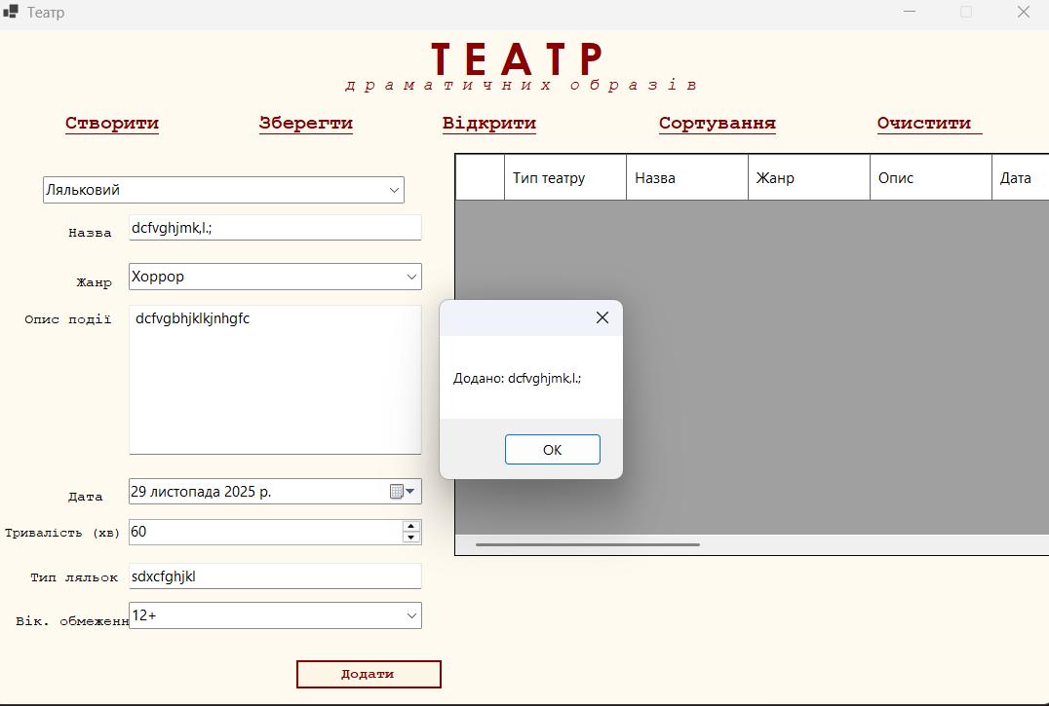
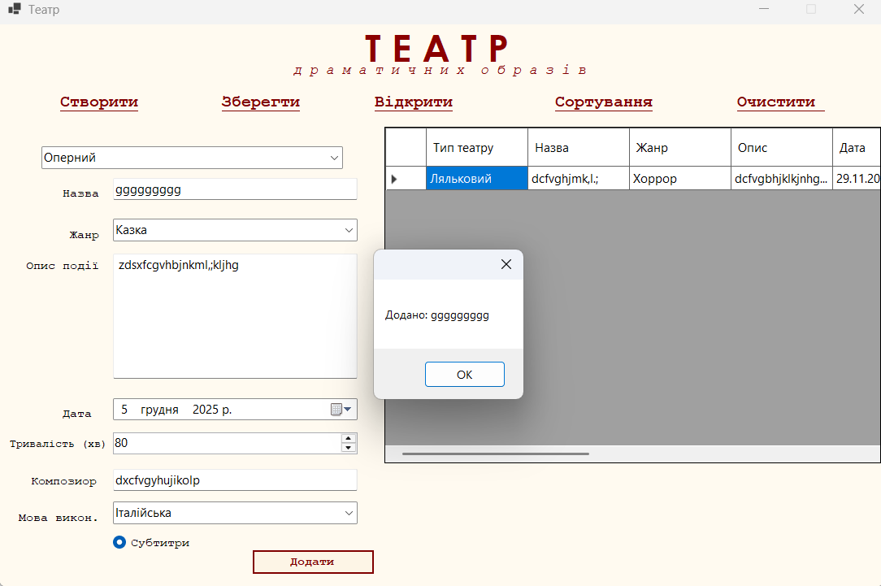

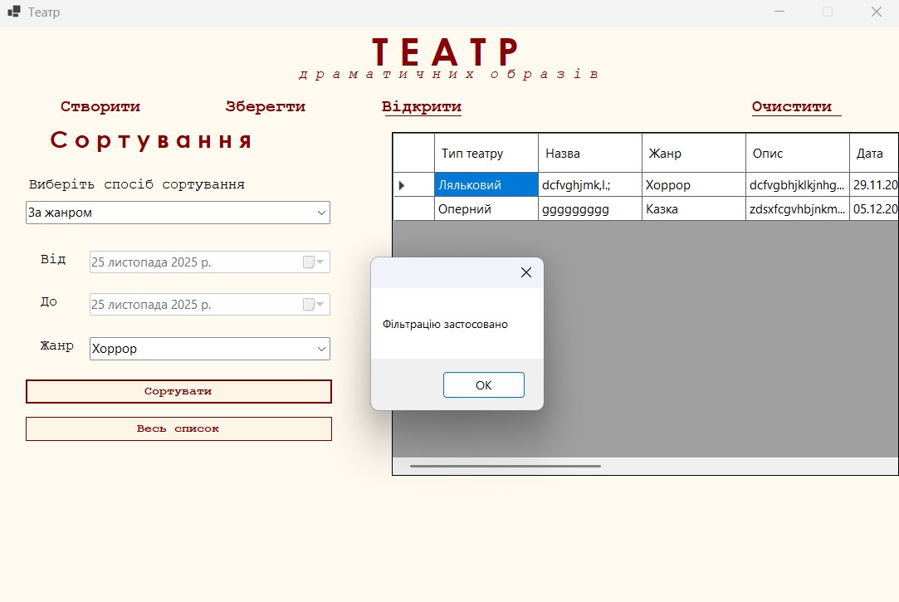

Висновок: ОДЕРЖАТИ ПРАКТИЧНІ НАВИЧКИ СТВОРЕННЯ ТА РОБОТИ З ДЕЛЕГАТАМИ.

